Camera Control Cubicle
The “Camera Cubicle” layout for a representative port is shown hereafter.

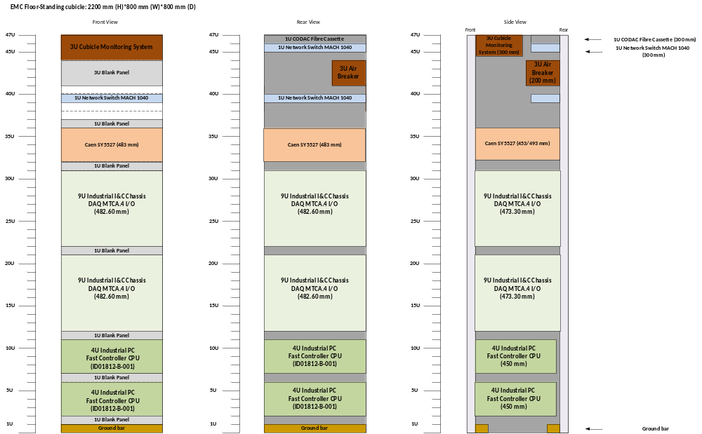

Power Allocation and Heat Load Analysis

The heat load requirements for a representative Camera Control cubicle are tabulated in Table 23 below. The following assumptions were made in this analysis:
I&C Chassis DAQ MTCA: the maximum absorbed power per unit was assessed on the basis of 80 W per used slots. 4 slots will be used per chassis: 2 single 10GigE Frame grabbers, a timing board (PTM-DAMC-1588-10F) and a board dedicated to communication with the Fast Controller (NAT-MCH-PHYS80).
Caen SY5527LC Power Supply (DC): The maximum absorbed power is 700W. As only 2 slots (out of 6) are used, we will consider a 300W maximum absorbed power for our configuration.
I&C Fast Controller CPU: The maximum absorbed power is 800W.

Table 23. Power and Heat Load Requirements for Camera Control Cubicles
Index | Description | Nb | Max. absorbed Power per unit (W) | Total Max absorbed Power (W) | Approximated heat emission (W)
1 | Network switch | 1 | 26 | 26 | 26
2 | Cubicle Monitoring System | 1 | 24 | 24 | 24
3 | MTCA.4 chassis | 2 | 320 | 640 | 640
4 | DAQ Fast Controller CPU | 2 | 800 | 1600 | 1000
5 | Power Supply | 1 | 230 | 230 | 230
 | Total |  |  | 2520 | 1920

